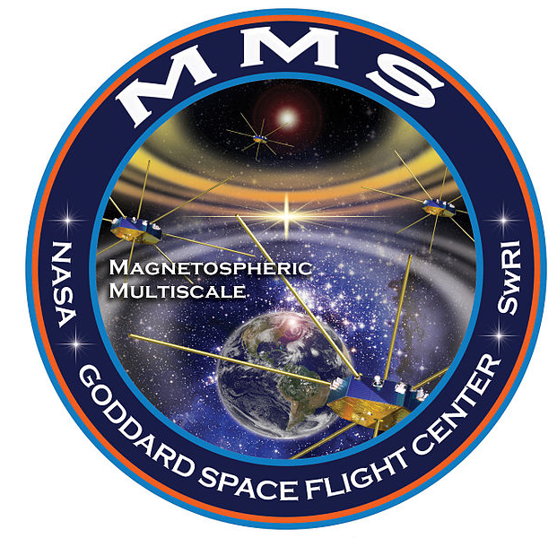



***MMS WORKSHOP***

***BERGEN***

***12-14 JUNE 2018***

***Scandic Ørnen Hotel***



**TUESDAY, 12. June** (Scandic Ørnen, Lars Hilles gate 18)

8:30-8:40 Hesse, M. Welcome and logistics

**DIFFUSION REGION PHYSICS** (Chair: Paul Cassak)

8:40-9:00 Burch, Jim Electron Scale Physics of Symmetric and Asymmetric Reconnection from MMS

9:00-9:20 Liu, YH Orientation and stability of asymmetric magnetic reconnection x-line

9:20-9:40 Trattner, Karlheinz The transition between anti-parallel and component magnetic reconnection at the Earth’s dayside magnetopause

9:40-10:00 Drake, J.F. A 3D Simulation of a MMS Magnetopause Reconnection Event with a strong

guide field

*10:00-10:30* *Coffee break and poster viewing*

10:30-10:50 Oieroset, Marit Strongly driven magnetic reconnection with flux pileup at the interface of colliding jets at the magnetopause

10:50-11:10 Cozzani, G. Diffusion region’s structure at the subsolar magnetopause using MMS data

11:10-11:30 Tang, Binbin MMS observations of electron crescent distributions at the flank magnetopause

11:30-11:50 Pritchard, Kristina Energization and Movement of Electrons within an EDR with emphasis

on the role of En

11:50-12:10 Egedal, Jan The kinetic structure of the electron diffusion region observed by MMS during asymmetric reconnection

*12:10-13:30 Lunch (on-site, included) and poster viewing*

**DIFFUSION REGION PHYSICS** cont’d

13:30-13:50 Yamada, Masaaki The two-fluid dynamics and energetics of the asymmetric magnetic reconnection in space and laboratory plasmas

**The July 11, 2017 Event** (Chair: Jim Drake)

13:50-14:10 Nakamura, Rumi Current sheet structure and evolution of 20170711 EDR event

14:10-14:30 Nakamura, Takuma Fully kinetic simulation of an EDR crossing event observed by MMS

on 11 July 2017

14:30-14:50 Hasegawa, Hiroshi Reconstruction of the magnetotail reconnection region seen by MMS

on 11 July 2017

14:50-15:10 Genestreti, K.J. How accurately can we measure the reconnection rate E_M for the MMS diffusion region event of 2017-07-11?

15:10-15:30 Denton, R.E. Determining the velocity of a magnetic structure, with application to the 11 July 2017 magnetotail reconnection event

*15:30-16:00 Coffee break and poster viewing*

**HEATING AND TURBULENCE** (Chair: Kevin Genestreti)

16:00-16:20 Eastwood, J.P. Guide field reconnection: exhaust structure and heating

16:20-16:40 Phan, T.D. MMS Observations of Electron Magnetic Reconnection without Ion Coupling in the Turbulent Magnetosheath

16:40-17:00 Ergun, R.E. Magnetic Reconnection, Turbulence, and Particle Acceleration

17:00-17:20 Hesse, Michael The role of separatrix instabilities in heating the outflow region

17:20-17:40 Argall, Matthew MMS observations of kinetic entropy in the reconnection diffusion region

17:40-18:00 Goldman, M. Multibeam energy transport

**GROUP PHOTO**

18:00 TBD location







**WEDNESDAY, 13. June** (Scandic Ørnen, Lars Hilles gate 18)

8:30-8:40 Announcements

**HEATING AND TURBULENCE** cont’d (Chair: Jason Shuster)

8:40-9:00 Eriksson, Stefan MMS Observations of Magnetic Reconnection Exhausts in the Solar Wind Associated with Tripolar Perturbations of the Out-of-Plane Magnetic Field

9:00-9:20 Graham, D.B. The role of lower hybrid waves in magnetic reconnection

9:20-9:40 Norgren, Cecilia Electron acceleration and thermalisation at magnetotail separatrices

9:40-10:00 Li, Wenya Electron Bernstein Waves driven by electron crescents near the

electron diffusion

10:00-10:30 Coffee break and poster viewing

10:30-10:50 Eriksson, Elin Electron energization at a reconnecting magnetosheath current sheet

10:50-11:10 Steinvall, Konrad Multi-Spacecraft Observations of Electron Holes

11:10-11:30 Holmes, Justin Interior structure of strong electron phase-space holes

**COLD AND HEAVY ION EFFECTS** (Chair: Tai Phan)

11:30-11:50 Tenfjord, Paul How Oxygen Influences the Reconnection Rate

11:50-12:10 Toledo-Redondo, Sergio Balance of the Ohm's Law under the presence of cold ions of ionospheric origin in magnetic reconnection: PIC simulations and MMS observations

12:10-13:30 Lunch (on-site, included) and poster viewing

**COLD AND HEAVY ION EFFECTS** cont’d (Chair: Tai Phan)

13:30-13:50 Alm, Love Influence of cold ions on magnetotail Hall physics

**SHOCK PHYSICS** (Chair: Joachim Birn)

13:50-14:10 Fuselier, Stephen High-speed jets downstream of the quasi-parallel bow shock

14:10-14:30 Schwartz, Stephen Kinetic Aspects of a Hot Flow Anomaly: MMS Observations

14:30-14:50 Johlander, Andreas Shock Ripples Observed by the MMS spacecraft: Ion Reflection and

Dispersive Properties

14:50-15:10 Khotyaintsev, Yuri Observation of Electrostatic Potential Structure and Ion Reflection for

a Rippled Perpendicular Shock

15:10-16:00 Starkey, Michael MMS Observations of He+ pick-up ions at Earth's perpendicular bow shock

15:30-16:00 Coffee break and poster viewing

**ADVANCED ANALYSIS METHODS** (Chair: Stefan Eriksson)

16:00-16:20 Cassak, Paul Kinetic Entropy as a Diagnostic in Particle-in-Cell Simulations of Magnetic Reconnection

16:20-16:40 Shuster, Jason Resolving Terms of the Vlasov Equation with MMS

16:40-17:00 Escoubet, C. Philippe Cluster MMS conjunctions tail 2018 and Cluster constellation 2019

(presented by Rumi Nakamura)

17:00-17:20 Toth, Gabor Studying reconnection in Earth’s magnetosphere using a global MHD

with embedded PIC model

17:20-17:40 Paterson, William Tuning Magnetospheric Multiscale’s Automated Burst System

17:40-18:00 Reiff, Patricia Using CCMC Modeling as Context for MMS Events

18:00-18:10 Spann, Jim NASA’s MMS GI program and other updates

18:30 WORKSHOP DINNER (Scandic Ørnen, food included, drinks for purchase)









**THURSDAY, 14. June** (Scandic Ørnen, Lars Hilles gate 18)

8:30-8:40 Announcements

**BBFS AND DIPOLARIZATION FRONTS** (Chair: Bob Strangeway)

8:40-9:00 Breuillard, Hugo 3D ion-scale dynamics of BBFs and their associated emissions in Earth's magnetotail using 3D hybrid simulations

9:00-9:20 Birn, Joachim Particle acceleration in dipolarization fronts

9:20-9:40 Pan, Dong-Xiao Properties of electron-scale structures at a dipolarization front

9:40-10:00 LeContel, Olivier Analysis of kinetic structures embedded in a fast earthward flow during

a substorm event

*10:00-10:30* *Coffee break and poster viewing*

**FLUX ROPES** (Chair: Elin Eriksson)

10:30-10:50 Hoilijoki, Sanni Observations of a small-scale flux rope-like structure next to an EDR at

the dayside magnetopause

10:50-11:10 Hwang, K.-J. Magnetotail reconnection following a flapping motion of the magnetotail

on 17 July 2017

11:10-11:30 Choi, E. Substructure of an ion-scale flux rope observed in the magnetotail

on 17 July 2017

11:30-11:50 Dogko, K. PIC simulation study of nonlinear upper-hybrid waves near EDR

11:50-12:10 Stawarz, J.E. Intense electric fields and electron-scale substructure within magnetotail

flux ropes as revealed by the Magnetospheric Multiscale mission

*12:10-13:30 Lunch (on-site, included) and poster viewing*

**BROADER MMS RESEARCH** (Chair: Mats Andre)

13:30-13:50 Strangeway, Robert Field-Aligned Currents as Observed by Magnetospheric Multiscale

13:50-14:10 Russell/Strangeway The Case for Dust Comets Striking the Magnetosphere

14:10-14:30 Lavraud, Benoit Four-spacecraft measurements of the size and dimensionality

of magnetic structures

14:30-14:50 Petrinec, S.M. On the Occurrence of Magnetic Reconnection Along the Dawn and

Dusk Magnetopause

14:50-15:10 Le, G. Poloidal and Toroidal Mode Field Line Resonances Observed by MMS

*15:30-16:00 Coffee break and poster viewing*

**WORKSHOP END**

16:00-17:00 **UIB Horizon Lecture**

Jim Burch and Michael Hesse: The most powerful explosions in space may not be   
 what you think they are

Location: Egget room, Student Center (Parkveien 1)

15:30-16:00 Reception

16:00-17:00 Lecture

https://www.uib.no/ift/118210/most-powerful-explosions-space-may-not-be-what-you-think-they-are









**POSTERS:**

Graham, D.B. Large-amplitude high-frequency waves at Earth's magnetopause

André, M. Cold ions at the magnetopause: Effects at various scales

Dogko, K. Multiple plasma wave modes in the magnetotail separatrix region on 17 July 2017

Choi, E. PIC Simulation of Kelvin-Helmholtz instability at the Dayside Magnetosphere

Hwang, K.J. FTE generated in the velocity shear layer of Kelvin-Helmholtz vortices

Moretto, T. Superdarn / MMS conjunctions

Payne, D. Poynting's Theorem During a Magnetotail EDR

Encounter by MMS

